**Student Registration System - Skills International**

Final Project Documentation for Level 3 Diploma

**Table of Contents**

1. **Introduction**
2. **Visual Studio**
3. **C#**
4. **Project Overview**
5. **System Features**
6. **Technical Implementation**
7. **Database Design**
8. **User Interface Design**
9. **Security Considerations**
10. **Testing and Validation**
11. **References & Tools Used**
12. **Introduction**

This documentation provides a detailed explanation of the **Student Registration System** developed as part of the Level 3 Diploma final project. The system is designed for **Skills International**, an educational institution, to manage student registrations efficiently.

**Purpose**

* Streamline student registration, updates, and deletions.
* Provide a secure login system for administrators.
* Display student records in a structured dashboard.

**Technologies Used**

* **Frontend**: Windows Forms (.NET Framework)
* **Backend**: C# with SQL Server for database management.
* **Tools**: Visual Studio, SQL Server Management Studio (SSMS).

1. **Visual Studio**

(Microsoft, 2023) Visual Studio is Microsoft's **integrated development environment (IDE)** used for building, debugging, and deploying applications across multiple platforms. It supports various programming languages, including **C#**, which was used to develop the **Student Registration System**.

**Key Features of Visual Studio**

* Code Editor with IntelliSense (smart code completion)
* Debugging Tools for error detection
* GUI Designer for Windows Forms applications
* Database Integration with SQL Server
* Extensions for additional functionality

**Why Use Visual Studio for This Project?**

* **Windows Forms Designer -** Easy drag-and-drop interface creation
* **SQL Server Integration -** Seamless database connectivity
* **Robust Debugging -** Helps identify and fix errors quickly
* **Project Management -** Organizes all project files efficiently

1. **C#**

(W3Schools, 2025)

* It is an object-oriented programming language created by Microsoft that runs on the .NET Framework.
* C# has roots from the C family, and the language is close to other popular languages like [C++](https://www.w3schools.com/cpp/default.asp) and [Java](https://www.w3schools.com/java/default.asp).
* The first version was released in year 2002. The latest version, **C# 13**, was released in November 2024.

**C# is used for:**

* Mobile applications
* Desktop applications
* Web applications
* Web services
* Web sites
* Games
* VR
* Database applications
* And much, much more!

1. **Project Overview**

The application consists of three main forms:

1. **Login Form** – Authenticates admin users.
2. **Home Dashboard** – Displays student records in a Data Grid View.
3. **Registration Form** – Allows CRUD operations on student data.

**Key Functionalities**

* **Login Authentication**: Validates admin credentials (Admin/Skills@123).
* **Data Management**: Add, update, delete, and view student records.
* **Navigation**: Switch between forms seamlessly.

1. **System Features**
   1. 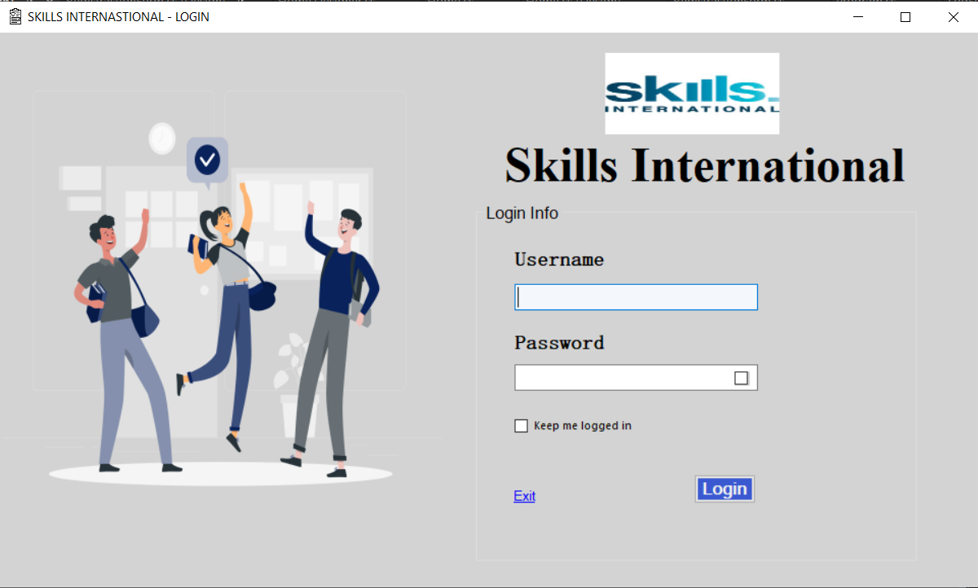**Login Form**

* **Username & Password Validation:** Ensures only authorized users access the system.
* **Password** **Visibility Toggle**: Checkbox to show/hide password.
* **Exit Confirmation**: Prompts before closing the application.
  1. 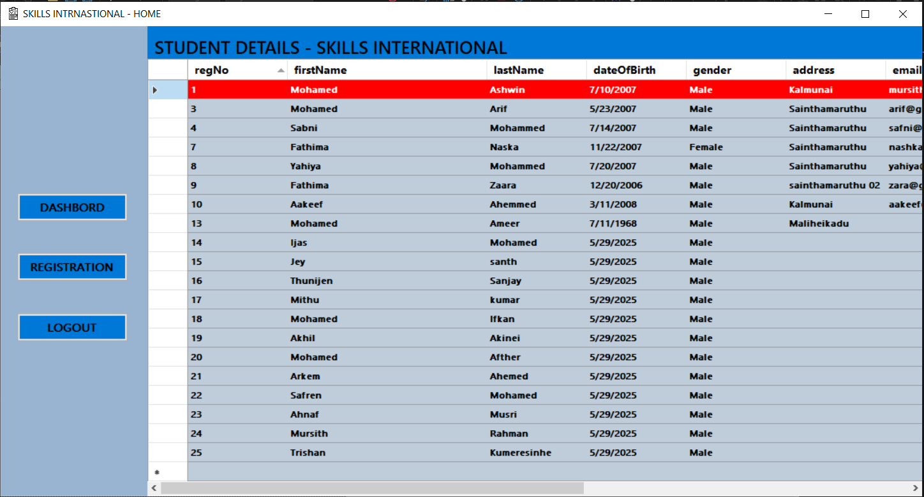**Home Dashboard (**Home**)**
* **Data Display:** Shows all student records in a scrollable grid.
* **Navigation Buttons:**
* Dashboard: Refreshes the current view.
* Registration: Opens the registration form.
* Logout: Returns to the login screen.
  1. 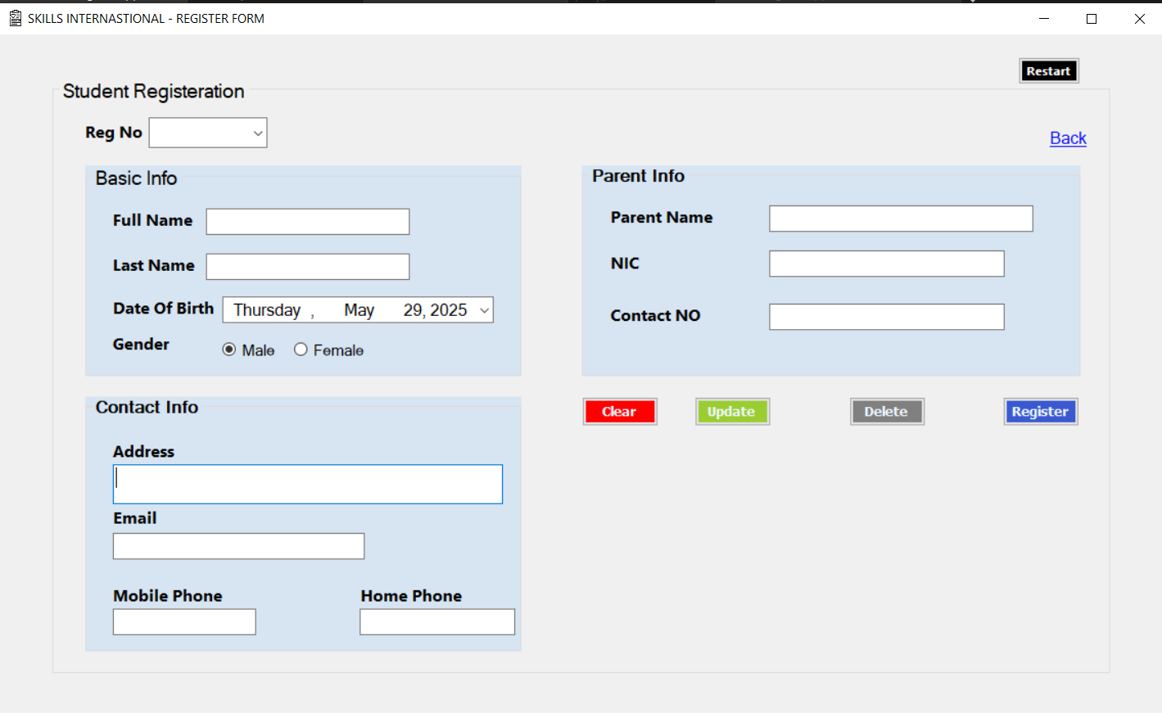**Registration Form**
* **Student Registration**: Captures:
* Personal details (Name, DOB, Gender).
* Contact info (Email, Phone, Address).
* Parent/Guardian details (Name, NIC, Contact).
* **CRUD Operations:**
* **Register**: Adds new students.
* **Update**: Modifies existing records.
* **Delete**: Removes records with confirmation.
* **Clear**: Resets input fields.
* **Dynamic Combo Box:**

1. **Technical Implementation**

**4.1 Frontend (Windows Forms)**

* Developed using **C#** and **.NET Framework**.
* Used **Data Grid View** for displaying student records.
* Implemented **event handlers** for buttons (Login, Register, Update, Delete).

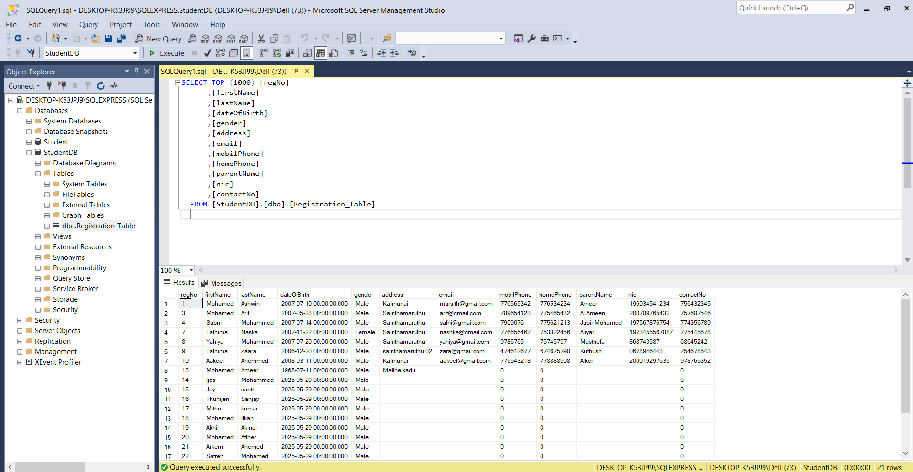 **4.2 Backend (SQL Server Database)**

* **Database Name**: Student DB
* **Table:**Registration Table
* **Primary Key:**reg No (Unique identifier for each student).

**4.3 Key Code Snippets**

* 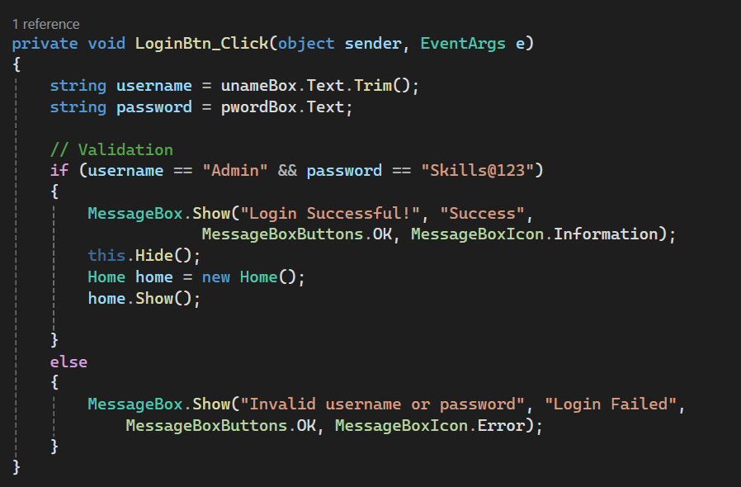**Login Validation:**
* **Database Connection:**
* 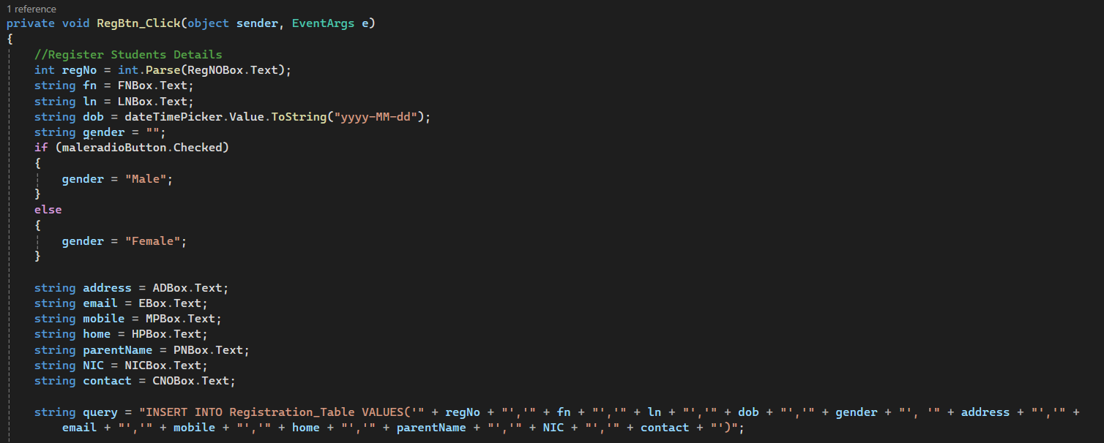**Register Button Code:**

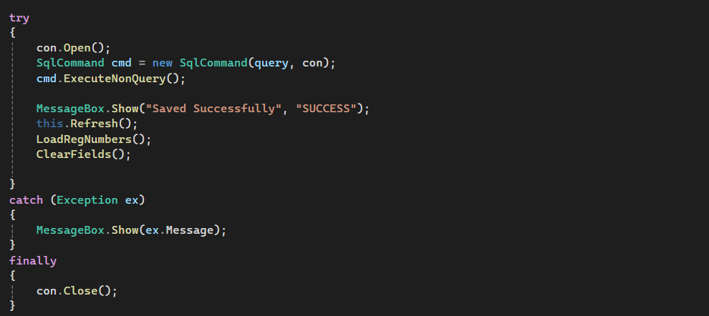

* 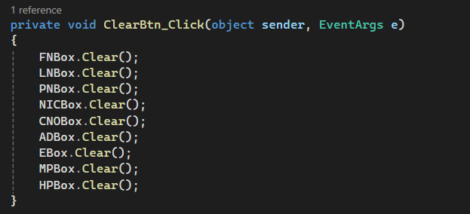**Clear Button Code:**
* 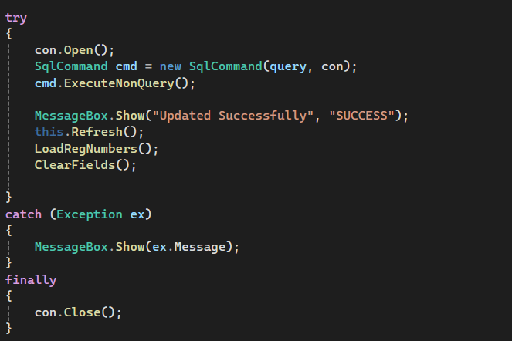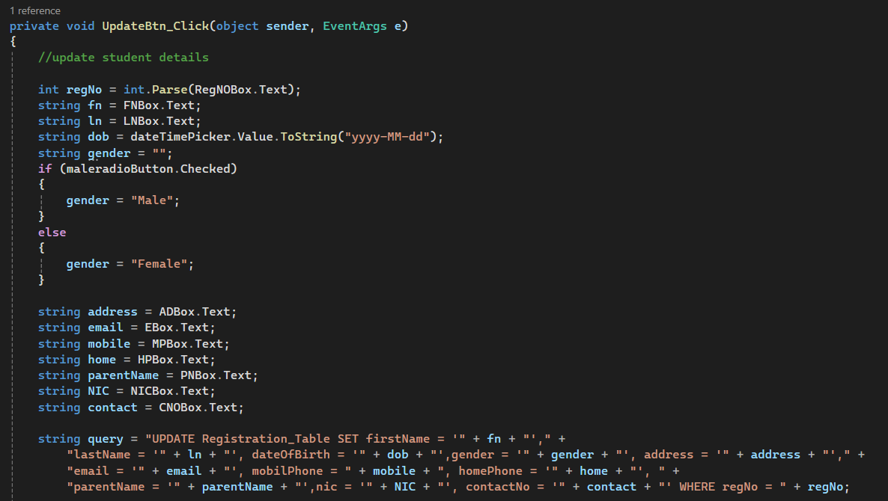**Update Button Code**
* 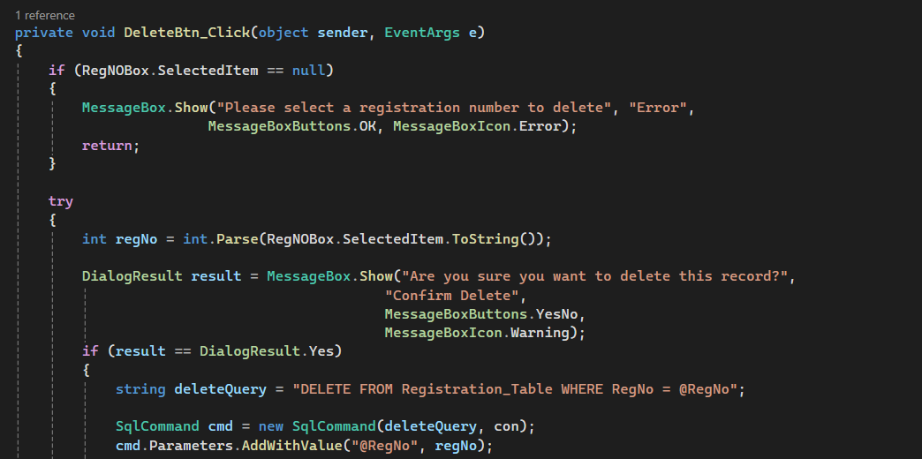**Delete Button Code**

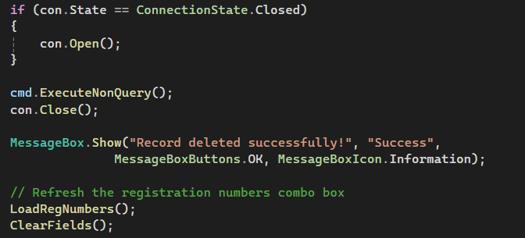

1. **Database Design**
   1. **Table Structure**

|  |  |  |
| --- | --- | --- |
| Column Name | Data Type | Description |
| Reg No | INT (Primary Key) | Student registration number |
| FirstName | VARCHAR (50) | Student’s first name |
| LastName | VARCHAR (50) | Student’s last name |
| DOB | DATETIME | Date of birth |
| Gender | VARCHAR (50) | Male/Female |
| Address | VARCHAR (50) | Residential address |
| Email | VARCHAR (50) | Email address |
| Mobile Phone | BIGINT | Mobile number |
| Home Phone | BIGINT | Home phone number |
| Parent Name | VARCHAR (50) | Parent/guardian name |
| NIC | VARCHAR (50) | National ID card number |
| ContactNo | BIGINT | Emergency contact number |

1. **User Interface Design**
   1. **Login Form**

* Clean and intuitive design.
* Error handling for invalid credentials.
  1. **Home Dashboard**
* Displays student records in a structured Data Grid View.
* Navigation buttons for easy access to other forms.
  1. **Registration Form**
* Grouped sections for Basic Info, Contact Info, and Parent Info.
* Combo Box for selecting existing student records.

1. **Security Considerations**

* **Password Protection**: Password field masked by default.
* **SQL Injection Prevention**: Parameterized queries used in database operations.
* **Confirmation Dialogs:** Ensures no accidental deletions**.**
* 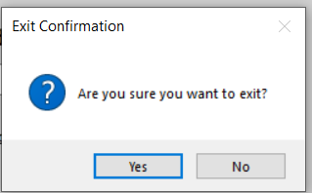Exit Confirmation:
* 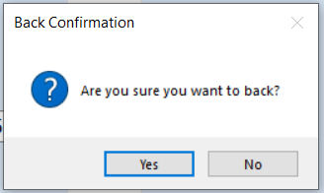Back Confirmation:
* 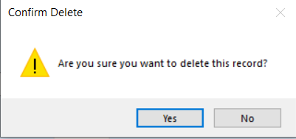Delete Confirmation:
* Logout Confirmation:

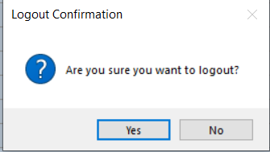

1. **Testing and Validation**

|  |  |  |
| --- | --- | --- |
| Test Cases | Expected Result | Actual Result |
| Login with correct credentials | Access to registration form | Pass |
| Login with incorrect credentials | Error message displayed | Pass |
| Register new student | Record added to database | Pass |
| Update exiting record | Changes saved to database | Pass |
| Delete record | Record remove from database | Pass |
| Clear form | All fields reset | Pass |

1. **References & Tools Used**

# **References**

Microsoft. (2023). *Visual Studio IDE Documentation.* Retrieved from Microsoft Docs: https://docs.microsoft.com/en-us/visualstudio/

W3Schools. (2025). *W#Schools/C#.* Retrieved from https://www.w3schools.com/cs/cs_intro.php.